07/22/2019
12:56 P.M.

To the churches and Christian family around the world,

I am here with a official message from the Most High. To give a decree of exactly what is now taking place before the world. At this very moment I am what you would call a persecuted Christian. By a covert group of gangstalkers who use 5G technology with direct energy warfare for V2K (voice to skull harassment) I have been wired up in my brain and other areas of my body primarily because I will not die. It was all installed into me while in a medically induced Coma at Creighton University Medical Center here in Omaha, Ne before they tore the hospital down completely.

This form of harassment is used by the 5G poles they are putting up all over the world that looks like next generation alien technology. Those targeted by this evil corrupt harassment are tortured by the way they use it against you using radiation, a evil computer device on their end that was made by Todd Shackelford a University of Nebraska Lincoln (UNL). A profound engineer of UNL for quite sometime. Todd’s son Christopher Shackelford is a member of the “gangstalkers” who has been given a sponged prison sentence that resulted from a vehicular manslaughter charge that killed a man on a motorcycle some time back here in Nebraska.

Omaha, Ne has gone completely corrupt and we are in our last days and I will explain why once I move on further. Ladies and gentlemen, there are reptilians amongst us everywhere. People who live 2 separate lives and you wouldn’t even believe it if they were directly in front of you now, that is how evil the world has become. Anyone of us may have a close friend whom we have known forever that has taken the mark of the beast implant in their right hands and you wouldn’t even know it.

They get this implant by “Community Engagment Agencies” Done by health care professionals mainly, the old family doctor perhaps. Either way we look at it, the chip is here amongst us all people, they aren’t scheduling individuals to line up at a crossroad to say yae or nae! They are doing it right under our noses. So I urge everyone to familiarize yourselves with what I am writing of and educate your children and close friends and family to mainly dissect anyone who has chosen the satanic path to destruction. Either way I am also here to say that they do not win, as the corrupt ex President Obama Said they will win the war on Christmas in which they will not! I myself and those who join my covenant and who walks uprightly will win the war. Nevertheless Christmas is a pagan holiday all together.

Jesus was not born December 25th. As I move along I will provide every example that is directly in scripture out of the Old Testament of the Holy Bible and particularly from the Psalms, the Psalms of David. First they made haste to develop the device to operate the form of torture. The wicked device also has the capability to produce a different image of the handler into a reptile state of a alienated form. 100% factual information.
“Psalm 21:11 For they intended evil against thee: they imagined a device they are not able to perform.”

You see brothers and sisters, I am anointed. They cannot perform this device on me. I’m not here to convince you all of this, I am here to tell you exactly the way it is and you have a choice from here on out, lets just hope you make the right choice because a very large number of people will be completely deceived by the pope and thinking he is Christ. In fact he will be the antichrist. Do not be fooled. He will sit in in the temple they have built in Israel who the people praise Donald Trump for being a big part in the new temple but I have a serious news flash for everyone. Jerusalem will fall directly from Zion into the new earth that will literally be Heaven on earth once all that comes to pass referring back to the antichrist, so do not be fooled. As it states in the Psalms of David,

“The fate of the fool” 14:7. Oh, that the salvation of Israel were to come out of Zion! When the lord bringeth back the captivity of his people, Jacob shall rejoice and Israel shall be glad.

Mitcham of David Psalms 16:5 The Lord is the portion of mine inheritance and if my cup: thou maintainest my lot. :6 The lines are fallen unto me in pleasant places: yea, I have a goodly heritage.

Brothers and sisters, that line is the Davidic line. Not only have I been persecuted, The bible state in the end the mother will war against the seed. Well I am that seed. That mother, earthly mother is Lisa Baker. I have been beaten while in a medically induced coma my jaw line fractured and other facial structure destroyed as well, my X-rays showed my jawline resembling something of a uneven chess board, they lined up to take shots at me because even after being electrocuted and put in a chamber of some sort I still had a pulse after every evil thing they did to try and kill me. Why was this done to me? The occult agenda, the occult my mother Lisa is a member of here in Omaha, “The One Thousand” She has hired countless hitman to kill my brother and I, they have never been successful throughout the years.

Psalms 7:12 a Shiggaion of David. If he turn not, he will whet his sword; he hath bent his bow and made it ready. 7 :13 He hath also prepared for him the instruments of death, he ordaineth arrows against the persecutors. This will be the portion of my enemies cup, as well as a fiery tempest. So their primary objective was to give me a shot and try multiple ways to kill me but every time outside of hospitals they can not come close to even touching my doors, they turn away suddenly and feel ashamed. My relative Talbray Floyd can attest to that, who the illuminati hired and took his soul by gangstalking him and humiliating him prior to him joining by thing that will be brought up in court.

So every health care professional, police officer, first responder, real estate company exedra or any other community engagement agency member gets exactly what they deserve of those still alive who the occult has not murdered and never heard of again paying even their own family members very large sums of money to remain quiet. Very evil times we live in and I say that so you don’t partake in the agenda that’s among us all.

My mothers life insurance policy is part of a occult sacrifice system, Levels. It is the devils final war plan. By wiring up my brain and other areas with implants at Creighton University Medical Center before they tore it down completely. I was the reason why that was. Life insurance policies is a sacrifice system of the child of older age. In which my mother has been completely engaged in. I recommend anyone reading this to look into anyone having a policy on yourself without your knowledge.

This happens everyday to a large number of Americans and those from other Countries. The devil knows his time is over, that is why we as Christians need to stand together and stand strong for the Lord more than ever before. A lot of Christians believe we will be rounded up by martial law and taken to Fema. Not everyone. Not those in my covenant. You are 100% safe and free from corruption.

They have laid a snare to where their own foot will be taken. As well as dug a pit where they will be sunk in. They wired my brain, given me a artificial Adams Apple, artificial blood clot in my left pulmonary artery, fractured and destroyed my entire facial structure while I was in a medically induced coma amongst other things that will be brought up in court and the public will know exactly what took place. Through it all I still had a pulse. I woke up days later and remember saying to a gentleman

“Hi Sir”

It is the worst feeling to have that it was orcastrated by my own mom. They wired up my brain to perform a device that Todd Shackelford invented a UNL engineer, using V2K (voice to skull technology) a form of extreme harassment for my very own self to be under the control of the occult and operated by my mother and the group of people she recruited as well. Including every single girlfriend I have had and my children’s mothers to set me up to die even knowing they could never kill ne prior to them taking her bribes. My son is missing up until this very day I have not seen him at all. He is my world. I beat 3 CPS cases my mother slandered me for, DHHS of Neb has been corrupt in Iowa and Neb, corrupt Hospitals all over the city and Iowa have falsified my medical records completely. The homeless shelter Micah House, Lisa makes false claims on mental health petitions forging signatures to put me in Lasting Hope Hospital and others and given fake diagnosis knowing who I am.

Community Engagment Agencies are apart of it all. They can not be trusted, many of you work directly with people who are not as they seem. With their computer that Todd created using 5G technology, the wicked looking next generation poles being put up across the country. They are able to harass us acting as and asking us if they want them to pull you up. (A form of selling your soul they repeatedly attempt to demonstrate on me, never will I wickedly depart from God.

The reasoning is I wont die so in retrospect they are in fear. They are humans but in being 100% honest they are able to become reptilians a form of alienated beings once engaged in their evil computer devices “gangstalkers” have in their own homes my mother even has a handheld device she is allowed to have at her job at UNMC pursuing, stalking and harassing me 24/7.

Do Not Fall For It. They are making haste to convert Christian leaders, whistleblowers and those that are woke and aware of the things that are taking place all over the world.

I know who is responsible and I mean everyone of this must about no one can hide because it will be a domino effect and the media will have no choice but to respond to mass number of us calling and making reports in terms of what Lisa Baker has done to me. So act any way possible, please. I strongly urge you.

They have imagined a evil device that they can not perform on Gods anointed. Up until this very moment they are still persecuting me with my family being fake, almost every member stuffing money into a policy for a increase they will never see. My mothers gangstalkers have used tactics that the bible states exactly what will happen in the last days, all to get me to my lowest point in my life to possibly commit suicide because I certainly will not die. I am the sovereign Lord of today the spirit is in me brothers and sisters.
I write these decrees because eventually I will bring the captivity back to Israel and the God of Jacob will rejoice. In the scripture, 2 Timothy to be accurate says: in the end times there will be lovers of money, slanderers, ext.. These are a few examples of the exact direction and tactics they have implicated towards me.

That makes me laugh when I think about it. You would think the leaders of this world and people we hope to direct us to be a nation that is ran with integrity have enough knowledge to understand by now that I can not die. I am David. The servant of God. The apple of Gods eye. I am here for a reason! To expose this agenda of the entire loss of their plan of the New World Order, lost hopes of a one world government. This time God acts. The generation is completely out of faith.

Donald Trump and the final Pope will have given a image to my people in Israel and they have built a temple for that they intended evil to reign but listen to the sovereign Lord and the prophecy against them all in Philistia, Tyre, Edom, Ammona, Sidon and Moab exactly as is states in the book of Ezekiel, I will take vengeance on them all in what it states in the scriptures.

Churches even have been flooded with sin, greed, gossip, and the jezebel spirit to distract the entire congregation. The devil is going after the masses. This is partly why a large number of you will completely overlook this decree and others I write as well. It is important from this exact point in your lives to clean up yourselves and your houses by getting down on your knees and go to God whole heartedly by confessing each and every sin you have ever done in your life and repenting talking to God from your heart without thinking you need to speak to him with a silver tongue.

Just be yourself and real, its worth being honest with yourself more than you ever have, God knows who you are you cant hide anything. So do not be afraid of honesty that’s what is needed from you and myself.

The primary example I am about to lay out is from our enemy. They are amongst us with the technology and devices they imagined even though they can not perform them on me, they relentlessly peruse me and my soul because they are tremendously afraid of the lack of explanation of why I can not die. This is that reason. I am here to tell of the decree, I am a persecuted Prophet. I don’t perform magic or spells or anything of that nature I am just a sheep right now amongst my people.

Soon, everyone will see and a vast number of individuals will be deceived by the pope. The Vatican entirely is corrupt and the primary reasoning behind any and every evil because the pope himself will get assassinated but I warn you! Do not be deceived what so ever he will be the ANTI CHRIST and never really dies in the first place because of the technology. He will also act as if his throne is in Jerusalem and even sit there taking away those that should be believing in this.

As the apple of Gods eye me and my offspring will inherit the earth. I will have spent 40 years by that time on this earth, I am 38 now. When I return, I will no longer be David but yet I remain from the Davidic line and decedent of Abraham through the God of Jacob. Jacob will rejoice once again when Israel is restored again, Jacob will rejoice!

I will have a pure crown of Gold upon my head as just as the pope will wear fooling a great deal of Christian followers. Stay strong and believe that the giant I have been facing of today will lose. The book of Psalms, Psalms of David the book written of me that my mighty right arm will bring me my victory. Are my tears not in my book?

All of us who believe will be victorious. This is why I need everyone to share this document with any one through Facebook, Twitter, Text messages, Family and Friends wherever they are right now with out any hesitation at all.

Look at examples below and understand that they are reptilians and evil workers of iniquity: 100% truth…politicians, actors, sports players, doctors, nurses, ext…are amongst us and have taken the chip. The mark of the beast. They have sold their souls. So hang onto it, they are harassing people everywhere claiming to be angels.

If you are getting this document with out the pictures below look on twitter under the prophet with the yellow star of David for my profile. Facebook David Baker with the star as well and a picture of me and my son Novah. He is still missing and has been molested by my mother. Exact sort of context they display while under the V2K torture.

Today my mother and Talbray Floyd claiming that Novah is with his mother Andrea Sprague who has been bribed by Lisa and apart of the gangstalker agenda. Also told by my mother not to return my son to me for a sum of cash. Andrea is deemed not fit to have any children in her care by DHS of Iowa and signed her rights away to her other child Dylan because of related drug offenses.

They will not let me file charges at all. A amber alert for him is needed. Please flood the police with calls about my son and myself being in danger every day and the lack of integrity of everyone involved in my family doing us like this for my love of my heavenly father.

Please for the sake of my Children and mankind all together. Get out of yourselves and day to day distractions because anything other than this is irrelevant, soon nothing will matter at all. So think about your families and friends and church members, He who hath an ear, Listen to what the spirit say unto the churches.
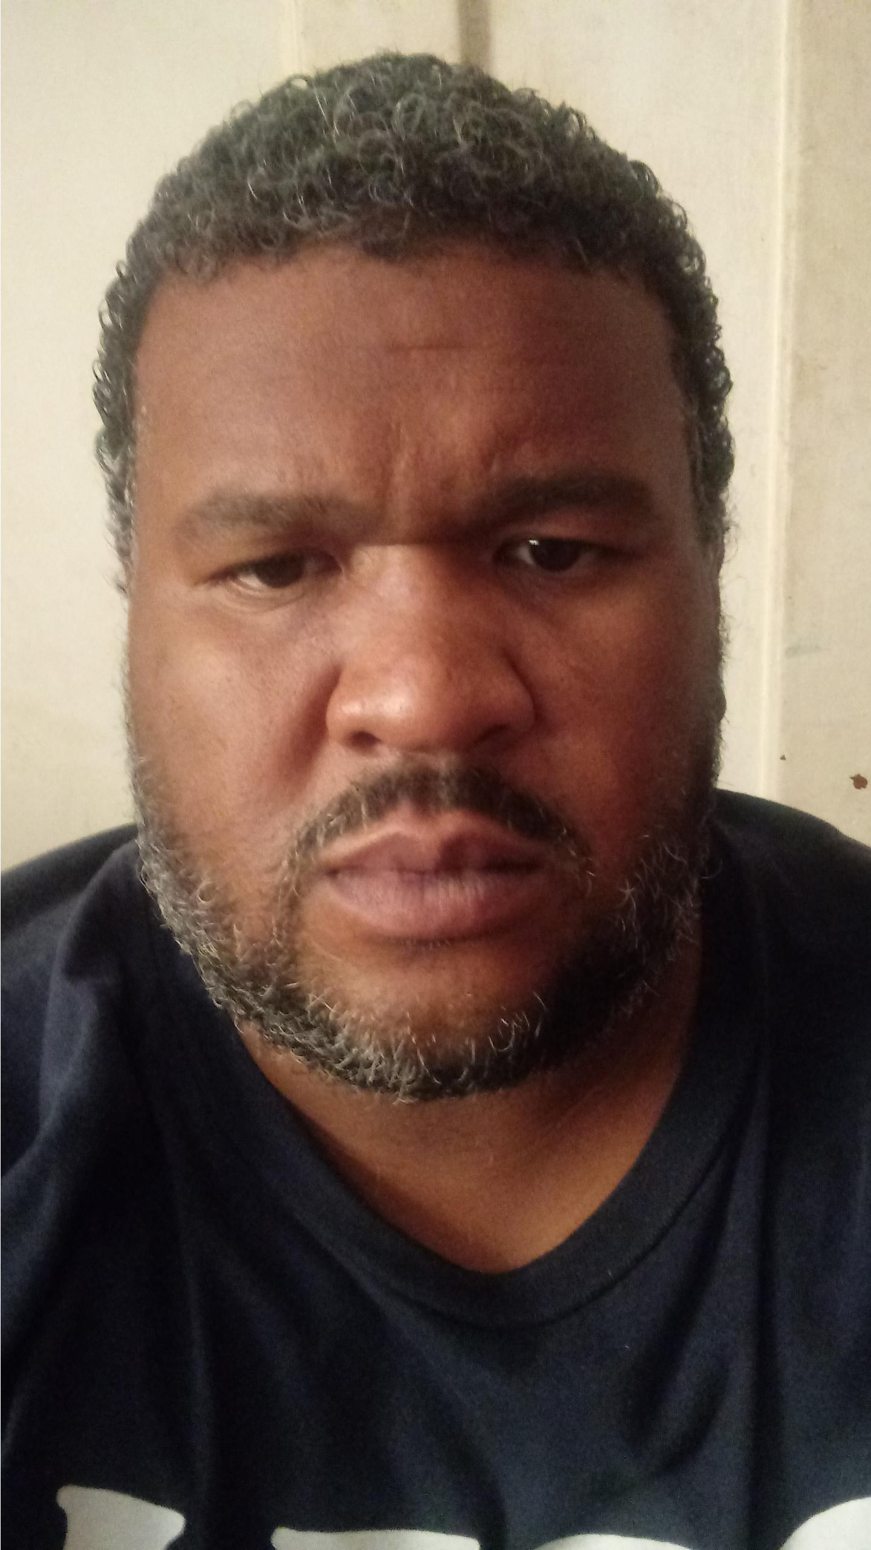
Me, David. I have been through more harassment and endured more pain than anyone else in this entire world. I miss my son they have him someplace. I need you.

My son Novah.
The pope, soon will claim to be Christ himself, me being who I am laughs. What a Joke! Literally.

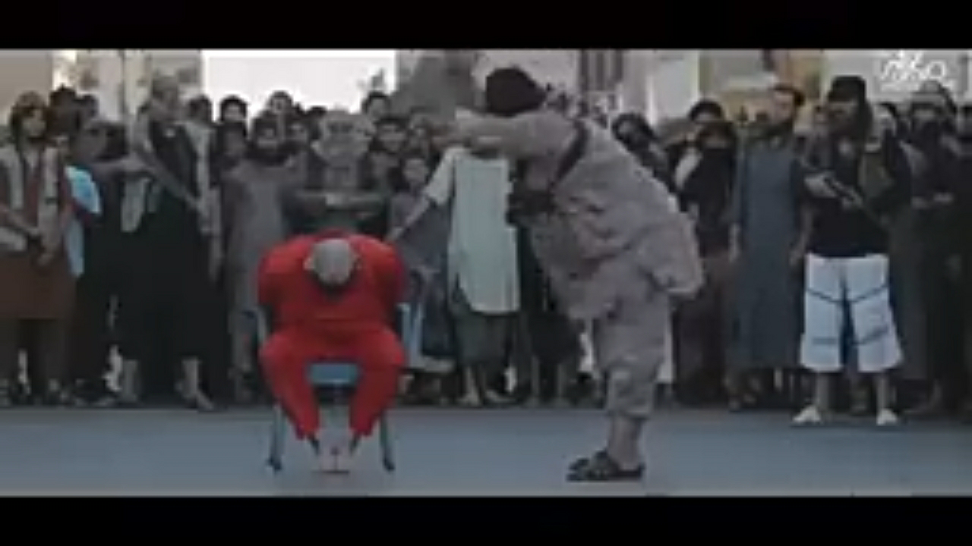

When I return, I will have a new name. I will throw him into the pit. Anyone who sold their souls or taken the chip by a community engagement agency will fry up. You will have the portion of your cup. God will soon prepare a table for me in the presence of my enemies, and my Cup Will Over Flow!

